附件1

新加坡原产地证书
（样本）

1.出口商(名称及地址) | 新加坡共和国  优惠原产地证书  证书号码：  未经授权不得对本证书内容进行增改
2.收货人(名称、地址及国家) | 新加坡共和国  优惠原产地证书  证书号码：  未经授权不得对本证书内容进行增改
3．启运日期 | 8. 出口商声明  兹申明本证书上的内容及说明正确无误。  签名:  姓名:  职称:  日期: 签章
4. 船舶名称/飞机航班号码 | 8. 出口商声明  兹申明本证书上的内容及说明正确无误。  签名:  姓名:  职称:  日期: 签章
5. 卸货口岸 | 8. 出口商声明  兹申明本证书上的内容及说明正确无误。  签名:  姓名:  职称:  日期: 签章
6. 最终目的地国 | 8. 出口商声明  兹申明本证书上的内容及说明正确无误。  签名:  姓名:  职称:  日期: 签章
7. 货物原产国 | 8. 出口商声明  兹申明本证书上的内容及说明正确无误。  签名:  姓名:  职称:  日期: 签章
9 .唛头及编号 10 . 包装号码及种类 11. 数量及单位
商品描述

(必要时包括品牌)
12． 主管机构证明

兹证明, 上述资料足以证明上述货物原产于第7栏所述的国家。
新加坡签发优惠原产地证书的填制说明
序号 | 描述 | 所需信息
1 | 出口商 | 新加坡出口商的中央注册号、姓名和地址。中央注册号是新加坡海关向进出口企业签发的唯一编号。
2 | 收货人 | 中国收货人的姓名和地址。
3 | 启运日期 | 船舶或飞机的离港日期。
4 | 船舶名称/飞机航班号 | 船舶的名称或飞机的航班号码。
5 | 卸货口岸 | 货物卸载的最终目的港。如货物经过转运, 航线的其他详细信息应在第10栏中列出, 或作为本证书的附页。
6 | 最终目的国 | 中国应为货物的最终目的国。
7 | 货物的原产国 | 货物的原产国应为新加坡。
8 | 出口商声明 | 出口商应在此栏中签名。
9 | 唛头及编号 | 货物的唛头及编号, 必要时可作为附页。
10 | 货物包装号码及种类; 商品描述 | 应在此栏中报明以下信息:  • 出口货物的商品描述，应和发票所列产品的商品描述相一致。准确的商品描述将有助于最终目的国海关加快货物通关。  • 每项货物的《协调制度》6位数子目。  • 每项货物的相应原产地标准 。  • 发票的编号和日期。根据第五章(海关程序)第36条(第三方发票)的规定, 由驻在非缔约方的公司或者在出口方为该公司代销的出口商开具。
11 | 数量及单位 | 货物的数量及其计量单位(如件、公斤等) 。
12 | 主管机构证明 | 出口方授权机构的签章。
 | 证书编号 | 出口方授权机构对所签发的每一份证书的唯一编号。

Singapore’s Certificate of Origin
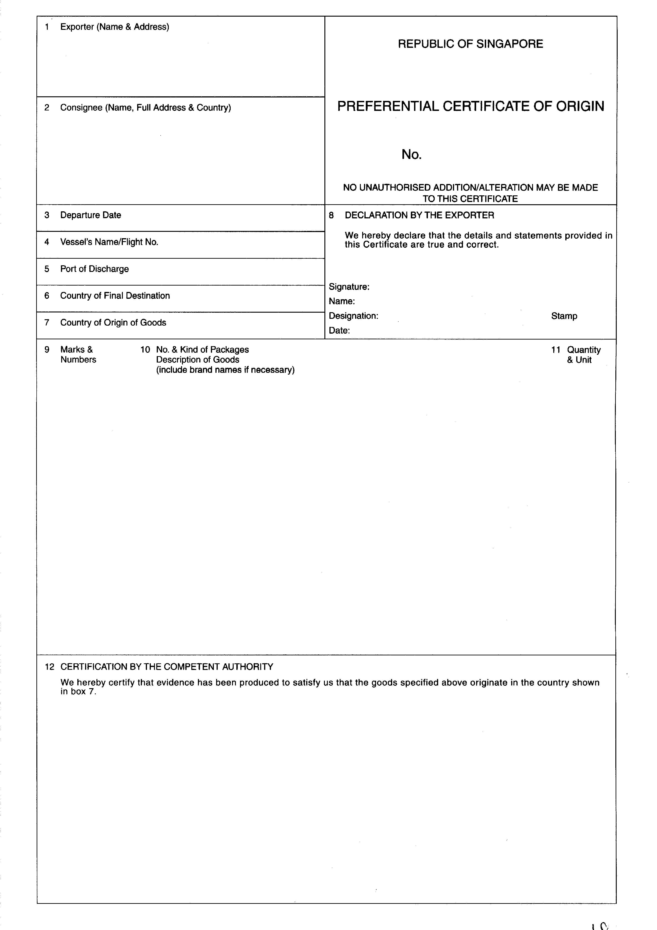

EXPLANATORY NOTES TO THE FORMAT OF PREFERENTIAL CERTIFICATE OF ORIGIN ISSUED BY SINGAPORE

Box  No. | Description | Type of Information Required
1 | Exporter | The Central Registration Number, name and address of the exporter in Singapore. The Central Registration Number is a unique number issued by Singapore Customs to companies which intend to import or export.
2 | Consignee | The name and address of the importer in China.
3 | Departure Date | The departure date when the vessel/aircraft left port/airport.
4 | Vessel’s Name/Flight No. | The vessel’s name or the aircraft flight number.
5 | Port of Discharge | The final port in which the goods will be discharged. Where goods are transshipped, the additional details of the route may be declared in box 10 or in a separate attachment to this Certificate.
6 | Country of Final Destination | The country of final destination will be China.
7 | Country of Origin of Goods | The country of origin must be Singapore.
8 | Declaration by the Exporter | The exporter will sign in this box.
9 | Marks & Numbers | The marks and numbers of the goods, to be attached in separate sheet, where necessary.
10 | Number & Kind of Packages; Description of Goods | The following information will be declared in this box:  •  The description of the products exported. This should be identical to the description of the products contained in the invoice. An accurate description will help the Customs Authority of the country of destination to clear your products quickly.  •  The 6-digit HS subheading for each product.  •  The relevant origin criterion for each product.  •  Number and date of invoices, issued either by a company located in a non-Party or by an exporter in the exporting Party for the account of the said company, as referred to in Article 36 (Third Party Invoicing) in Chapter 5 (Customs Procedures).
11 | Quantity & Unit | The quantity and its unit of measurement (such as pieces, kg) of the goods.
12 | Certification by the Competent Authority | Seal or stamp of the authorised body of the exporting Party.
 | Certificate Reference Number | A unique number will be assigned to each Certificate issued by the authorised body of the exporting Party.

附件2

《中华人民共和国政府和新加坡共和国政府自由贸易协定》项下进口货物原产资格申明

本人___________（姓名及职务）为进口货物收货人/进口货物收货人代理人（不适用的部分请划去），兹声明编号为____________的报关单所列第______项货物原产自新加坡, 且货物符合《中华人民共和国政府和新加坡共和国政府自由贸易协定》原产地规则的要求。
本人申请对上述货物适用《中华人民共和国政府和新加坡共和国政府自由贸易协定》协定税率，并申请缴纳保证金后放行货物。本人承诺在自货物进口之日起1年内补交《中华人民共和国政府和新加坡共和国政府自由贸易协定》原产地证书。

签名：____________
日期：____________

附件3

中国原产地证书格式（样本）： 正 本

1.货物启运自 (出口商的名称、地址、国家) |  |  |  | 证书号码：  中国-新加坡自由贸易区  优惠税率  原产地证书  (申请表格和证书合一)  签发国______________  （填制方法详见证书背面说明）
2. 货物运输至 (收货人的名称、地址、国家)

3．运输方式及路线（就所知而言）  离港日期  船舶/飞机等的名称  卸货口岸 |  |  |  | 4. 供官方使用  可享受中国-新加坡自贸区优惠关税待遇  不能享受优惠待遇（须说明理由）：  ..................................................................  进口国官方机构的授权人签名
5. 项目号码 | 6.唛头及包装号码 | 7. 包装数量及种类、商品描述(包括数量以及进口国的HS编码) | 8. 原产地标准（详见背页说明） |  | 9.毛重或其它计量单位及FOB价格 | 10.发票号码及日期
11．由出口商申报  兹申明上述填报资料及说明正确无误，所有货物产自  （XX国家）  且符合中国-新加坡自贸区原产地规则的相关规定，该货物出口至  （XX进口国）  地点、日期及签名 |  |  | 12．证明  根据实际监管，兹证明出口商的申报正确。  地点、日期、签名及签证机构印章
背页说明
第一栏：应填写中国出口商的法人全称、地址（包括国家）。
第二栏：应填写新加坡收货人的法人全称、地址（包括国家）。
第三栏：应填写运输方式、路线，并详细说明离港日期、运输工具的编号及卸货口岸。
第四栏：不论是否给予优惠关税待遇，进口方海关必须在相应栏目标注(√ )。
第五栏：应填写项目号码。
第六栏：应填写唛头及包装号码。
第七栏：应详细列明包装数量及种类。详细列明每种货物的商品描述，以便于海关关员查验时识别。商品描述应与发票所述及《协调制度》的商品描述相符。如果是散装货，应注明“散装”。在商品描述末尾加上“***”（三颗星）或“＼”（斜杠结束号）。第七栏的每种货物应填写《协调制度》六位数编码。
第八栏：若货物符合原产地规则，出口商必须按照下列表格中规定的格式，在第八栏中标明其货物享受优惠关税待遇所依据的原产地标准：
出口商申明其货物享受优惠关税待遇所依据的原产地标准 | 填入第八栏
（1）中国-新加坡自贸区原产地规则规定在出口方完全获得的产品 | “P”
（2）区域价值成分≥40%的产品 | “RVC”
（3）符合产品特定原产地规则的产品 | “PSR”
第九栏：毛重应填写“千克”。可依惯例填写其他计量单位，例如体积、数量等，以准确反
映其数量。FOB价格应在此栏中注明。
第十栏：应填写发票号码及开发票的日期。
第十一栏：本栏必须由出口商填写、签名并填写日期。应填写签名的地点及日期。
第十二栏：本栏必须由签证机构的授权人员填写、签名、填写签证日期并盖章。

China’s Certificate of Origin：

Original (Copies)
 |  |  |  |  | Reference No.
1. Goods consigned from (Exporter's business name, |  |  |  |  | CHINA-SINGAPORE FREE TRADE AREA
address, country) |  |  |  |  | PREFERENTIAL TARIFF
 |  |  |  |  | CERTIFICATE OF ORIGIN
 |  |  |  |  | (Combined Declaration and Certificate)
2. Goods consigned to (Consignee's name, address,
country) |  |  |  |  |  |  |  | Issued in ______________
 |  |  |  |  |  |  |  |  | (Country)
 |  |  |  |  |  |  |  |  | See Notes Overleaf
3. Means of transport and route (as far as known) |  |  |  |  | 4. For Official Use
Departure date |  |  |  |  |  |  |  | Preferential Treatment Given Under CHINA- SINGAPORE
 |  |  |  |  |  |  |  | Free Trade Area Preferential Tariff
Vessel's name/Aircraft etc. |  |  |  |  |  |  |  | Preferential Treatment Not Given (Please
 |  |  |  |  |  |  |  | state reason/s)
Port of Discharge
 |  |  |  |  | ..................................................................................
 |  |  |  |  |  | Signature of Authorised Signatory of the Importing
 |  |  |  |  |  | Country
5. Item | 6. Marks and | 7. Number and type of |  |  |  | 8. Origin criterion |  |  | 9. Gross | 10. Number and
number | numbers on | packages, description of |  |  |  | (see Notes |  |  | weight or | date of
 | packages | goods (including quantity |  |  |  | overleaf) |  |  | other quantity | invoices
 |  | where appropriate and HS |  |  |  |  |  |  | and value
 |  | number of the importing |  |  |  |  |  |  | (FOB)
 |  | country)
11. Declaration by the exporter |  |  |  |  | 12. Certification
The undersigned hereby declares that the above |  |  |  |  | It is hereby certified, on the basis of control
details and statement are correct; that all the goods |  |  |  |  | carried out, that the declaration by the
were produced in |  |  |  |  | exporter is correct.
.............................................................
(Country)
and that they comply with the origin requirements
specified for these goods in the China-Singapore
Free Trade Area Preferential Tariff for the goods
exported to
.............................................................
(Importing Country)
............................................................. |  |  |  |  | ................................................................................
Place and date, signature of |  |  |  |  | Place and date, signature and stamp of
authorised signatory |  |  |  |  | certifying authority

OVERLEAF INSTRUCTION

Box 1: State the full legal name, address (including country) of the exporter in China.
Box 2: State the full legal name, address (including country) of the consignee in Singapore.

Box 3: Complete the means of transport and route and specify the departure date, transport vehicle, port of discharge.
Box 4: The customs authorities of the importing country must indicate (√ ) in the relevant boxes whether or not preferential tariff treatment is accorded.

Box 5: State the item number.

Box 6: State the shipping marks and numbers on the packages.

Box 7: Number and type of packages shall be specified. Provide a full description of each good. The description should be sufficiently detailed to enable the products to be identified by the Customs Officers examining them and relate it to the invoice description and to the HS description of the good. If goods are not packed, state “in bulk”. When the description of the goods is finished, add “***” (three stars) or “ \ ” (finishing slash). For each good described in Box 7, identify the HS tariff classification to six digits.
Box 8: If the goods qualify under the Rules of Origin, the exporter must indicate in Box 8 of this form the origin criteria on the basis of which he claims that his goods qualify for preferential tariff treatment, in the manner shown in the following table:

The origin criteria on the basis of which the exporter claims that his goods qualify for preferential tariff treatment | Insert in Box 8
(a) Products wholly obtained in the exporting Party as defined in China-Singapore FTA Rules of Origin | “P”
(b) Region value content ≧ 40% | “RVC”
(c) Products satisfied the Products Specific Rules | “PSR”

Box 9: Gross weight in Kilos should be shown here. Other units of measurement e.g. volume or number of items which would indicate exact quantities may be used when customary; the FOB value shall be indicated here.

Box 10: Invoice number and date of invoices should be shown here.

Box 11: The field must be completed, signed and dated by the exporter. Insert the place, date of signature.
Box 12: The field must be completed, signed, dated and stamped by the authorised person of the certifying authority.

